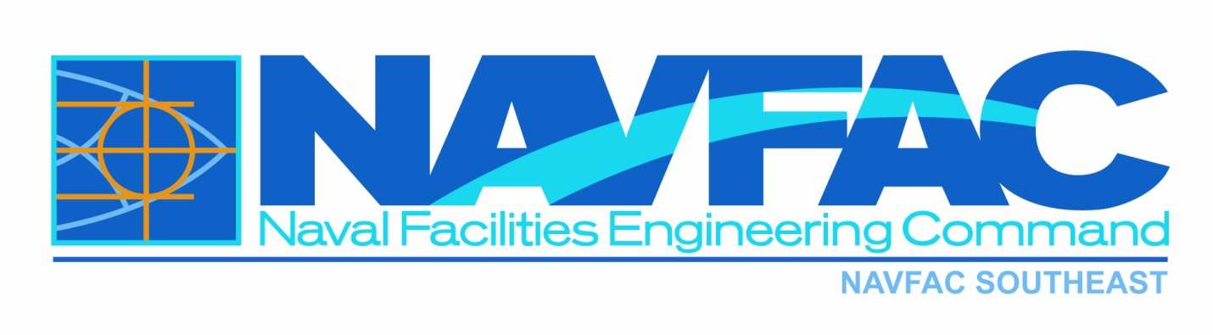

SOUTHEAST

MAXIMO 7.6

NAVFAC MAXIMO DIRECT ENTRY PROCEDURES
NAVFAC SOUTHEAST TRAINING MANUAL
N69450-xx-xxxx
Mayport BOS

Table of Content

- THE PURPOSE OF SERVICE REQUEST/WORK ODRER…………………………….………page 3

- QUERYING A SERVICE A REQUEST……………………….…………………………………page 4 - 5

- HOW TO CREATE SERVICE REQUEST.………………………………………………….…page 6 – 10

- THE WORK ORDER……………………………………………..…………………..……………page 11 – 19

- APPROVING THE WORK ORDER…………………………………………………….…………….page 20

- ENTERING LABOR AND MATERIAL…………………………………………………………page 21– 30

- COMPLETING THE WORK ORDER…………………………………………….……………………page 31-32

- HOW TO CREATE AN ASSET……………………………………………………………………page 32-37

- HOW TO DCR AN ASSET………………………………………………………………………..Page 37-39

The Purpose of Service Request/Workorder
This document will cover the fields necessary for a person to create and managing Service Requests and Workorders in Maximo. It gives an overview of NAVFAC SE data requirement for Service Requests/Workorders. Although the Regional Call Center enter all Emergency, Urgent, and Service tickets; there will be ocassions when an indivdual will need to enter Planned work in Maximo, (examples: Projects both Minor and Specific and PMs).

Service Requests Application
The Service Requests application is used to manage requests for services that involve an asset or location at your site. For example, a request to repair an outlet or fix a piece of equipment.

Service requests include requests that are communicated to you directly from a user, for example from a phone call, e-mail message, direct contact or from an automated workflow process. The owner of a service request is responsible for managing the ticket to completion. The ownership of a service request can be assigned to another individual or a workgroup. The assigned person is responsible for the request from creation to completion.

The ticket identifies who the service affects and what priority it has; it specifies why the service request might be escalated. If an issue arises the status can be changed as the request moves toward completion. All communication that pertains to the service request can be stored in the log of the service request to provide a clear history of its lifecycle. A service request record captures information about a request, including the type of service, who needs it, where, when, and why. The Service Request is used to manage requests for services that involve an asset or location in your enterprise.

Work Order Tracking Application
The Work Order Tracking application is used to plan, review, and approve work orders for assets and locations. When you generate a work order, you initiate the maintenance process and create a historical record of work being performed. This Module tracks past and present work and helps you plan for future work.

QUERYING A SERVICE REQUEST

From the Start Center go to: 1. Favorite Applications, 2. My Recent Application, or 3. Go to Applications. After you selected the ‘Service Requests’ applications, the SR module will display.
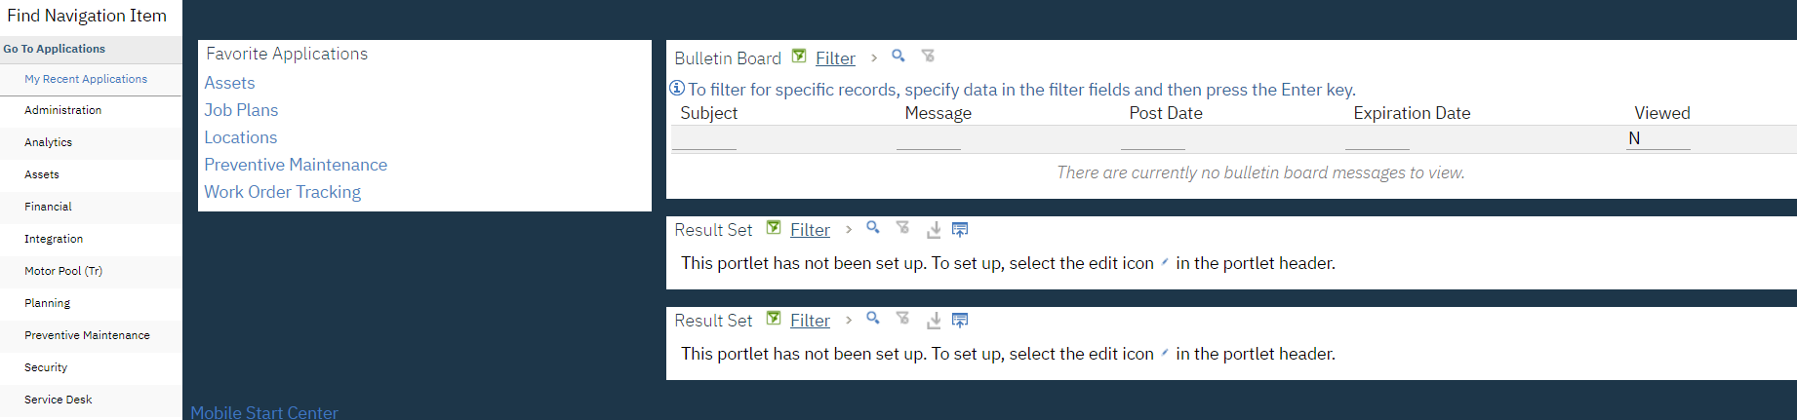
Then click on the advance search.
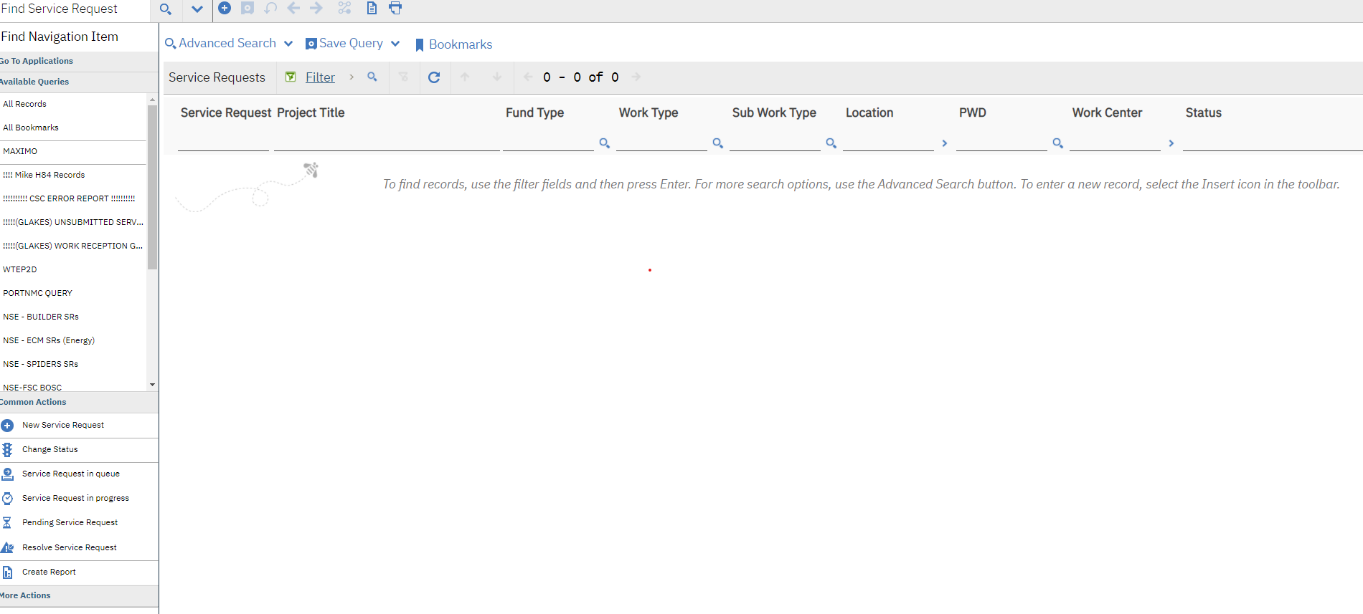
Advance search has a major over haul in the SR module; after the major field, all other fields have been arranged in Alphabetical order.

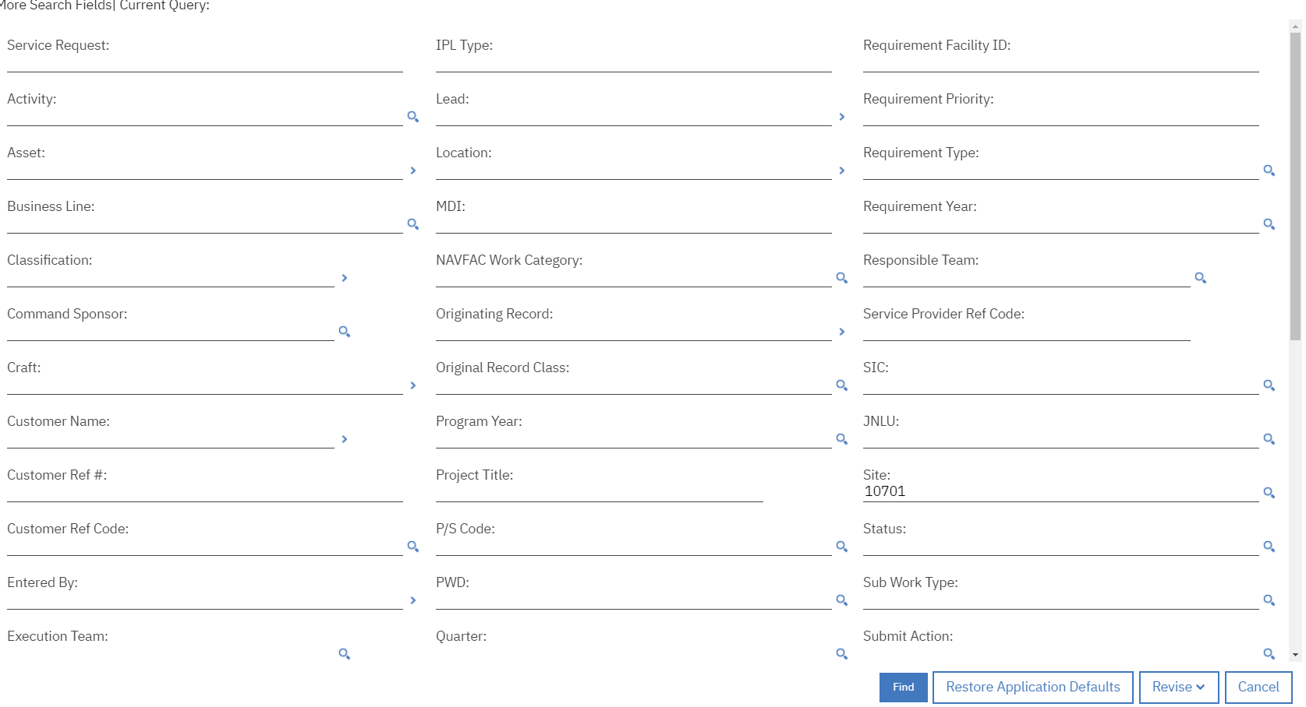

QUERYING A SERVICE REQUEST

If you are looking for a specific Service Request (SR), you can enter the number:
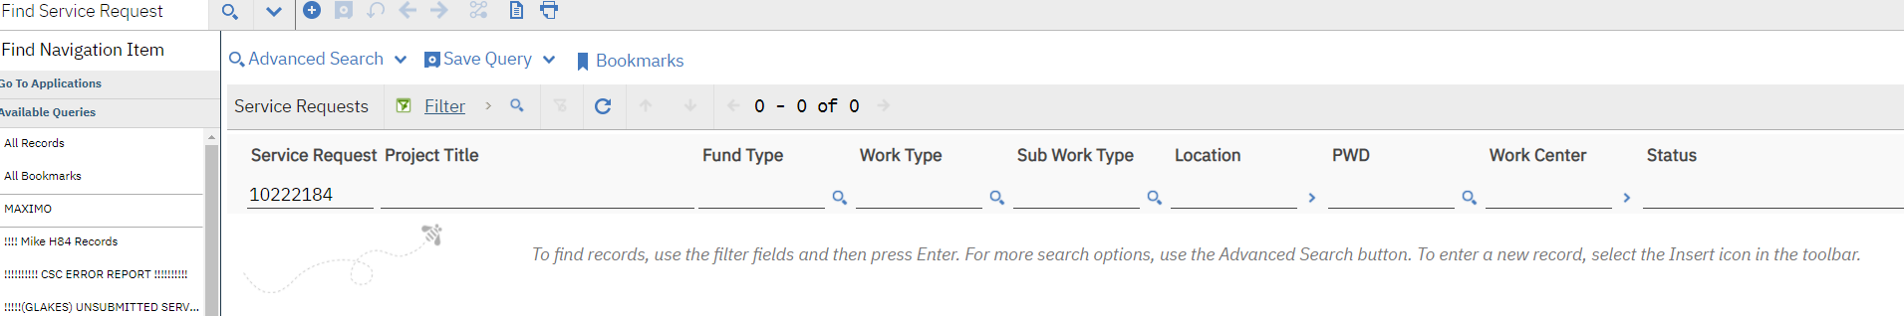
Once you click on the Service Request it will be displayed.

Then you will see a detailed report.
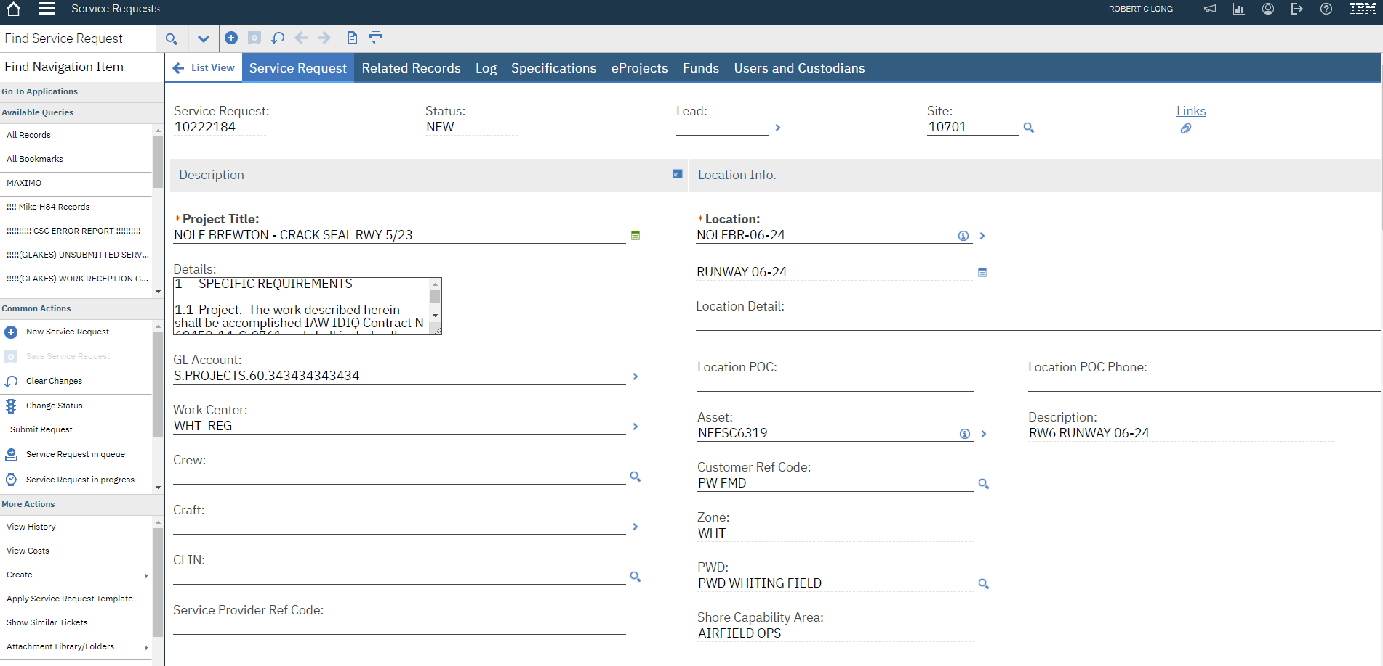

HOW TO CREATE SERVICE REQUEST
To get to the Service Request or the Work order Tracking Module from the Start Center you can get there three ways:
- Favorite Applications
- My Recent Applications
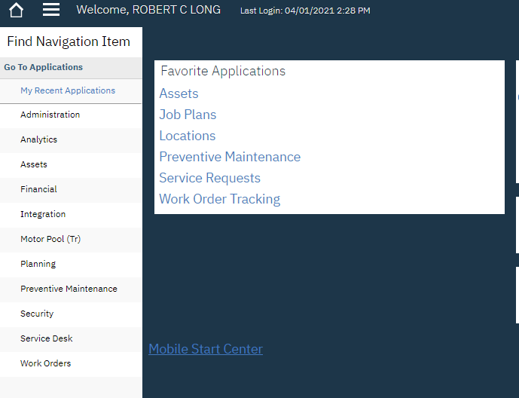
- Go To Applications

Click ‘New Service Request’ button
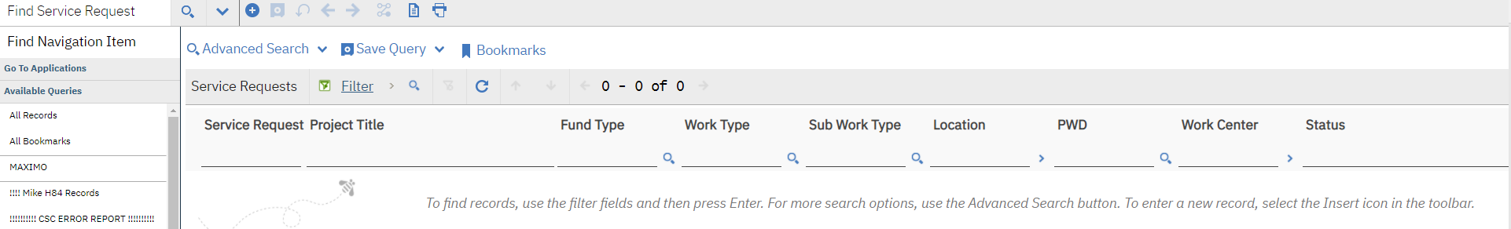

A Always use ALL CAPS when entering Service Request information.
B All red field are required to save the Service Request.
C NOTE: (+ indicates that an Attribute is required before you can submit the Service Request.)
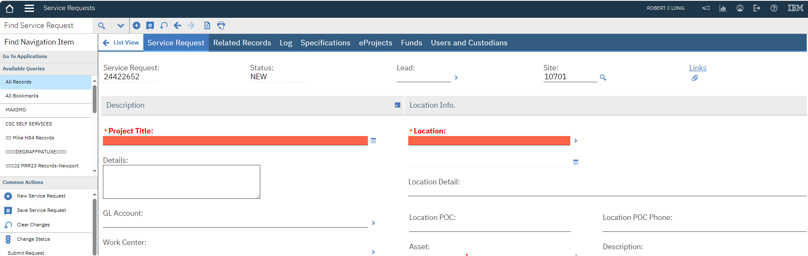
HOW TO CREATE SERVICE REQUEST
Service Request: – number is auto-populated by Maximo.
- Status: – When creating a new Service Request the status will be ‘NEW’.
- Lead: – Blank, if the Lead is known it can be populated.
- Site: – Auto-populate with 10701 for Southeast.
- 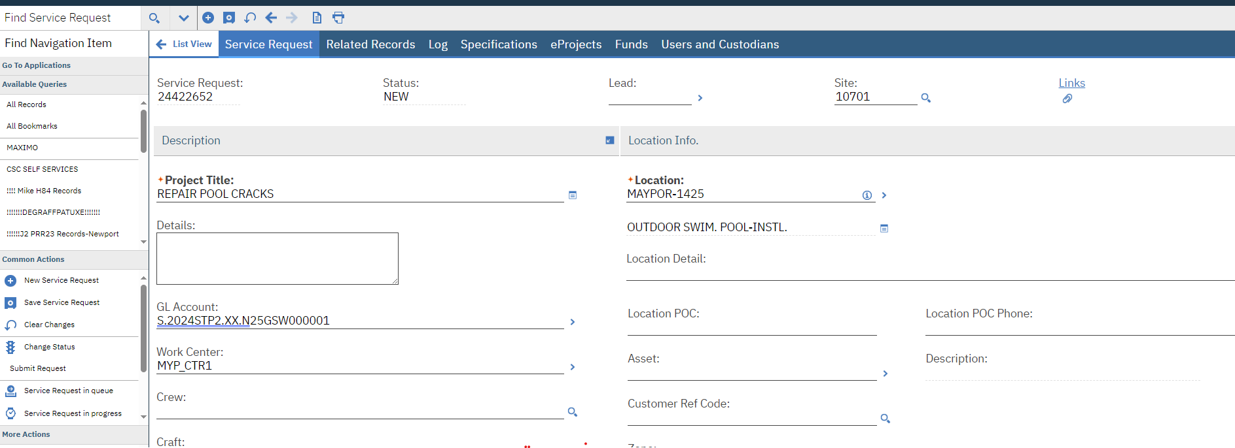
DESCRIPTION
- Project Title: – Brief description of the work needed. (Repair pool cracks)
- Details (Long Description) – Provide detailed information regarding the ticket.
- GL Account – The Job Order number (Customer’s JON paying for the Job. The GL account number:). S.2024STP2.XX.N25GSW000001 THIS NUMBER CHANGES EVERY FISCAL YEAR. (VALUE LIST)
- Work Center – Work Center that will perform the Work (MYP_CTR1). (VALUE LIST)
- Craft – The Craft assign to this type of work. (VALUE LIST)
- Crew – The Crew assign to this type of work. (VALUE LIST)
- CLIN – This is for BOSC Bases, the ELIN (example MYP-18D1800-A002BA). (VALUE LIST)
- Service Provider Ref Code – The BOSC Work order number.

HOW TO CREATE SERVICE REQUEST
LOCATION INFO
- Location – Site where is the work going to be performed. Locations are identified by the Base Area name and the facility number (MAYPOR-1425), this location is in Mayport and the facility number is 1425.
NOTE: If a new location needs to be enter in Maximo, a STS ticket needs to be submitted.
- Location Description – Name of the location, auto-populate from the Location application. (VALUE LIST)
- Location Detail – Any addition specify detail to describe the locations.
- Location POC – Person at the location that should be contacted.
- Location POC Phone – The location POC phone number.
- Asset – The Asset number, if work is to be performed on an Asset. (VALUE LIST)
- Customer Ref Code – Customer identification assigned to each customer. (VALUE LIST)
- Zone – Auto-populate from the Location. (VALUE LIST)
- PWD – Auto-populate from the Location. (VALUE LIST)
INFO
- Work Type – The classification of the work assigned to the Service Request (SR) (example ROUTINE). (VALUE LIST)
- Sub Work Type – The second level of work associated to the SR that is derived from the Work order (example FACILITIES). (VALUE LIST)
- Information Section
Work Type | Sub-Work Type | When used
Routine  Urgent  Emergency | Facilities | Used for Annex 1502 Service Orders. These work order are created by RCC. Contractor manages the work order and close out.
PM | Facilities | Used for the contractors schedule work. These work order are created by contractor. Contractor manages the work order and close out.
Routine  Emergency | IMP Facilities | Used for IMP programs where the Government identifies problems with the system. These work order are created by RCC. Contractor manages the work order and close out.
Project | FPCT | Used for work within the contractor limits of liability. These work order are created by RCC. Contractor manages the work order and close out.
Routine  Urgent  Emergency | Utilities | Used for Annex 1604 Service Orders. These work order are created by RCC. Contractor manages the work order and close out.
PM | Utilities | Used for the contractors schedule work. These work order are created by contractor. Contractor manages the work order and close out.
Routine  Emergency | IMP Utilities | Used for IMP programs where the Government identifies problems with the system. These work order are created by RCC. Contractor manages the work order and close out.

- Activity – A Navy Installation within a Facilities Engineering Command (FEC). This field auto-populates when a valid GL Account is applied to the Service Request (example RBOSCNTR). (VALUE LIST)

CATEGORY
- Business Line, P/S Code / NAVFAC Work Category – For Emergency, Urgent, and Routine Work types BL/PS Code/Work Category will be auto-populated for you. (Any auto-populated field can be changed) (example; Business Line: PW, P/S Code H1, NAVFAC Work Category: 4)
- Submit Action – Tell the status of the created Work order.
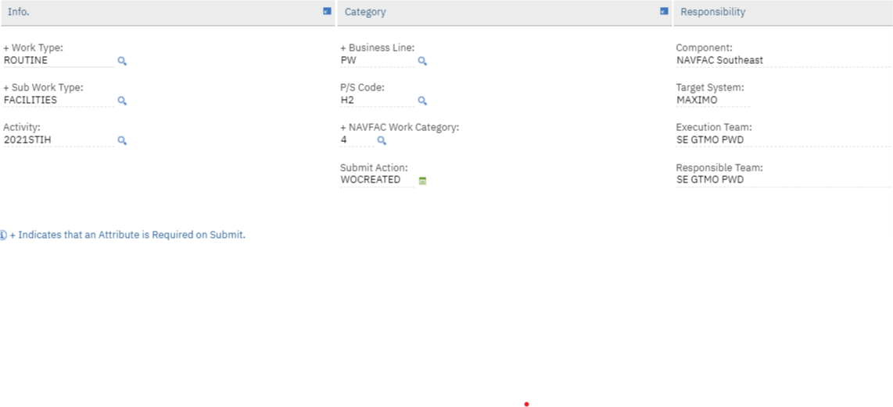
RESPONSIBILITY – This section is auto-populated by Maximo.
- Component – Component Command responsible for the SR. (NAVFAC Southeast)
- Target System – Denote the system that the Work order will be managed according on the entries on the Business Line, P/S Code, NAVFAC Work Category (either Maximo or eProjects).
- Execution Team – Auto-populate from Location.
- Responsible Team – Auto-populate from Location. HOW TO CREATE A SERVICE REQUEST
USER INFORMATION
- Reported Date/By/Name/Phone/E-Mail – Auto populates with the current date and the user’s information of the person entering the ticket (information can be modified).
- Customer ID Name/Phone/E-Mail/Customer Reference # – This is the building manager responsible for the building. Use the Detail Menu to select the caller’s name. If the caller name exists in the PEOPLE table their information will auto-populate after you enter the ‘Customer ID’. If name does not exist, enter an STS ticket to have information added to Maximo.
- Affected Date – Date when user was affected by issue. Auto-populated
- Entered By – Login/user name of the person entering the SR. Auto-populated
- Entered Date – Actual date of the SR was entered into the system. Auto-populated
- Modified By – The last person to change the SR. Auto-populated
- Modified Date – The date on which the SR was changed. Auto-populated
REQUIREMENT INFORMATION – NOT REQUIRED FOR CMMB PROJECTS
- Requirement Priority – The urgency of the work needed.
- Requirement Cost – The cost of the work needed.
- Requirement Category – CIMU, RPIE, or BOTH
- Requirement Type – Type of work needed to fulfil the requirement
- Requirement Year – The year the requirement need to be fixed.
- Requirement Facility ID – The build number that needs the work performed.
IPL INFORMATION - NOT REQUIRED FOR CMMB PROJECTS
- IPL Type – Integrated Product List Type associated to the SR. (VALUE LIST)
- Project# – IPL Project Number associated to the SR.
- Program Year – Indicates the IPL Program Year of the SR if applicable. (VALUE LIST)
- Quarter – IPL Quarter associated with the SR if applicable. (VALUE LIST)
- Command Sponsor – The Command Sponsor code is defined as a sub-designator indicating the Command Sponsor for the identified special project requirement. (VALUE LIST)
- Preponderant User – The significant user UIC.
- Users UIC – Identifies the users UIC.
- IPL Priority – Integrated Product List Priority associated to the Service Request. (VALUE LIST)
- Priority Score – Integrated Product List Priority Score associated to the Service Request.
- Work Class – The Work Class code is defined as a sub-designator indicating the work class for the identified requirement. A Work Class shall be chosen from the drop-down list in Maximo and used in conjunction with IPL Type and Funding Type. (VALUE LIST)
- SIC – The SIC code is defined as a sub-designator indicating the SIC for the identified special project requirement. A SIC shall be chosen from the drop-down list in Maximo and used in conjunction with the IPL Type, Funding Type, and Work Class codes. (VALUE LIST)
HOW TO CREATE A SERVICE REQUEST

- Funding Type – Identifies the Funding Type of the Service Request. (VALUE LIST)
- Expected Cost – The Expected Cost of the Service Request.
SERVICE REQUEST DETAILS - NOT REQUIRED FOR CMMB PROJECTS
- UNIFORMAT Master System – Identifies the UNIFORMAT Master System to the Service Request if applicable. (VALUE LIST)
- Classification – When you specify a classification for an object, you can organize related parent and child objects in a hierarchical structure, similar to a file directory. You can then drill up and down through the hierarchy to view associated items. Create and manage classifications in the Classifications application. (VALUE LIST)
- Class Description – Description of the classification specified for this record. (VALUE LIST)
- Reported Priority – Priority of Service Request as determined by person making the request. (VALUE LIST)
- Internal Priority – Priority of the Service Request as determined by the Service desk agent. (VALUE LIST)
DATES
- Target Start – The Target Start Date for the Service Request.
- Target Finish – The Target Finish Date for the Service Request.
- Actual Start – Actual Start Date. Enter a date or click the Select Date button and select a date.
- Actual Finish – Actual finish date. Enter a date or click the Select Date button and select a date.
GLOBAL ISSUES
- Is Global Issue – Flag used to determine if a Ticket/Service Request is a Global issue.
- Global Ticket – If it is a Global issue the number of the ticket. (VALUE LIST)
- Global Ticket Class – Identifies the Class of the global ticket.
MULTIPLE ASSETS, LOCATIONS
- Asset/Location/Target Description/Sequence/Mark Progress?/Site –If more than one Asset is assigned to this Service Request; you can add by clicking ‘New Row’.
After entering and checking all pertinent data; SAVE THE RECORD.
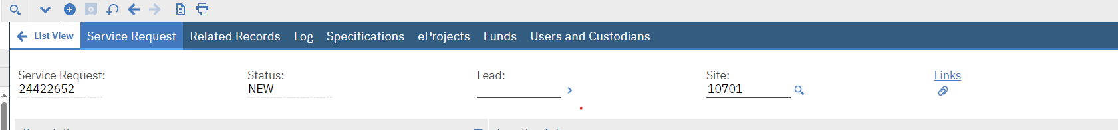
THE WORKORDER
Submit the ‘Service Request’ to convert the Service Request into a Work order; on the ‘Common Actions’ menu, select the ‘Submit Request’ icon.
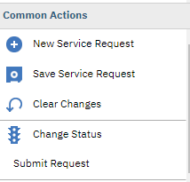
SYSTEM MESSAGE: The message you will receive is: ‘BMXZZ0007E - Are you sure you want to submit this Service Request? More information. Click ‘Yes’.
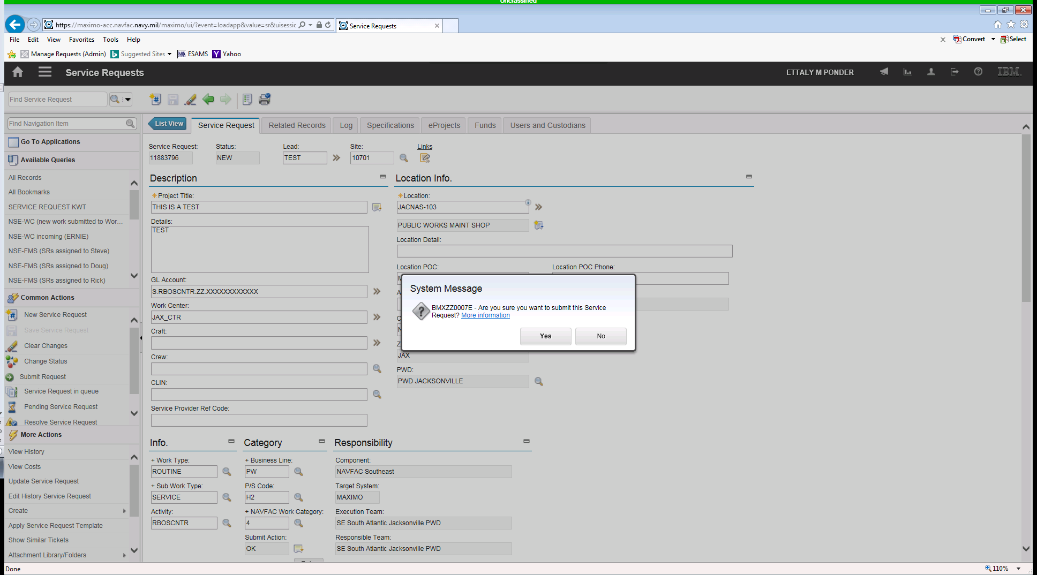
The next message is: BMXZZ0006E - Work Order XXXXXX is created successfully in the Submit Request Process. Click ‘OK’.
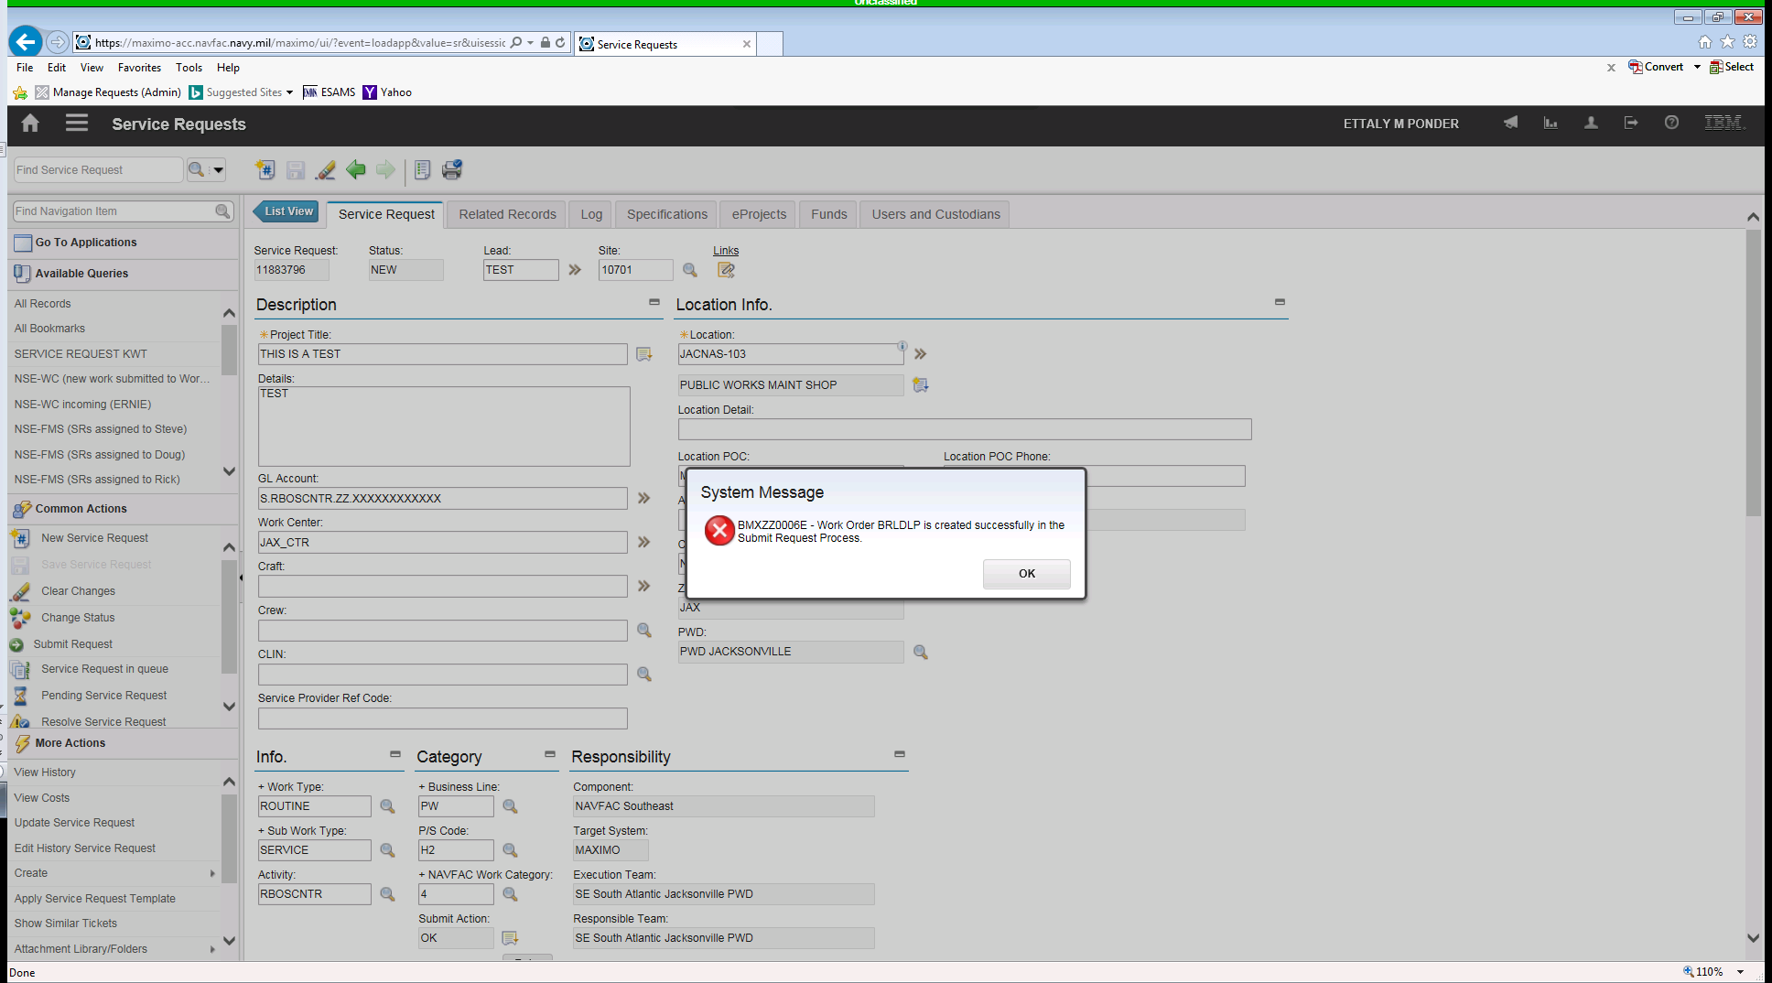
The Status will change from ‘NEW’ to ‘REQUESTED’.
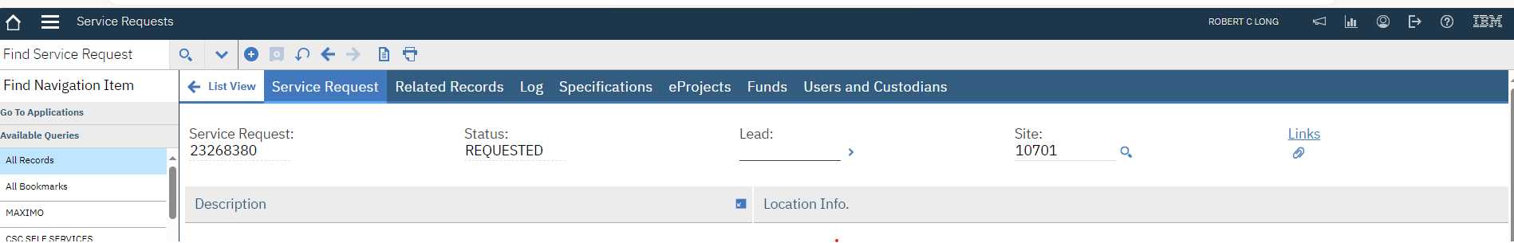

THE WORKORDER
Go to the Related Records tab and the Work order number will be displayed under ‘Related Records Detail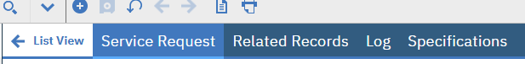
Click on the double arrow next to the Work order, then ‘Go To’, and then ‘Work Order Tracking’.
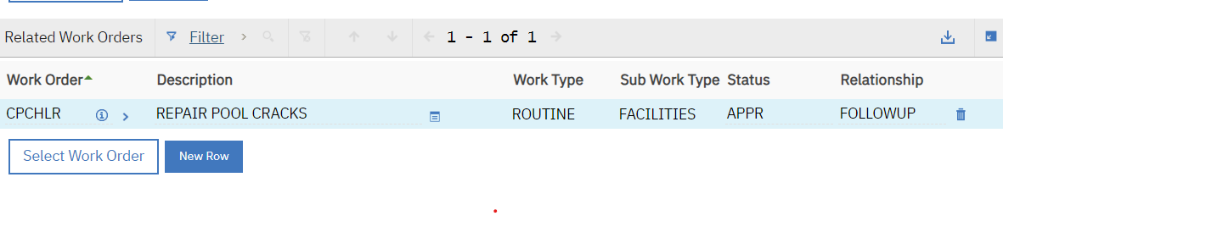
Maximo will take you to the Work order application; this will allow you to modify the Work order, if data needs to changed or add data as needed, before you approve the Work order.
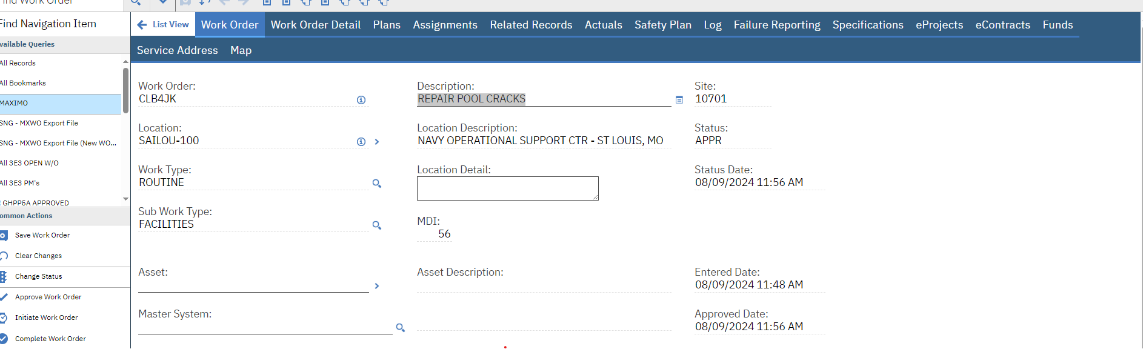
THE WORK ORDER
WORKORDER DETAIL TAB
- Work Order – Identifies the Work order auto-populated by Maximo.
- Location – Identifies the work orders Location. This is not necessarily the asset’s location; however, if an Asset is entered its location will default to the Asset Location. (VALUE LIST)
- Asset – Identifies the Asset associated with the Work order. (VALUE LIST)
- Parent WO – Parent of the Work order shown in the Work order field. If the field is blank, the Work order in the Work order field is a top-level Work order. To assign a Work order to a parent, Select Assign to New Parent from the Select Action menu.
- Work Center – Identifies the person group responsible for the work. (VALUE LIST)
- Lead – Lead person responsible for the work. (VALUE LIST)
- Classification – When you specify a classification for an object, you can organize related parent and child objects in a hierarchical structure, similar to a file directory. (VALUE LIST)
- Launch Entry Name – Description of the classification specified for this record.
- Failure Class – Failure class of the defined work asset. The failure class is the top level of the failure hierarchy. (VALUE LIST)
- Problem Code – The Problem being reported based on the defined Failure Class. This is usually the code in the second level of the failure reporting hierarchy. (VALUE LIST)
- Project Number – IPL Project Number.
- CLIN – Contract Line Item Number. (VALUE LIST)
- Type Service – Service Item Number. (VALUE LIST)
- SIC – The special project requirement. A SIC shall be chosen from the drop-down list in Maximo and used in conjunction with the IPL Type, Funding Type, and Work Class codes. (VALUE LIST)
- Command Sponsor – The command sponsor code is defined as a sub-designator indicating the Command Sponsor for the identified special project requirement. (VALUE LIST)
- Supported Command Program – (NOT USED IN SE)
- Reimbursable – Work order reimbursable?
- Description (work order) – Describes the Work order, to enter additional information, click the Long Description button.
- Description (location) – Description of the locations. To enter or view additional information, click the Long Description button.
- Description (asset) – Description of the Asset.
- Work Type – The classification of the work assigned to the Service Request (SR). (VALUE LIST)
- Sub Work Type – The second level of work associated to the SR that is derived from the Workorder. (VALUE LIST)
- Activity – A Navy Installation within a Facilities Engineering Command (FEC). This field auto-populates when a valid GL Account is applied to the Service Request. (VALUE LIST)
- GL Account – The Job Order number (customer JON paying for the Job). The GL account number is S.2024STP2.XX.N25GSW000001. THIS CHANGES EVERY FISCAL YEAR. (VALUE LIST)

THE WORKORDER

- Master System – UNIFORMAT classification for Buildings and Assets. (VALUE LIST)
- System – UNIFORMAT classification for Buildings and Assets. (VALUE LIST)
- Sub-System – UNIFORMAT classification for Buildings and Assets. (VALUE LIST)
- Business Line – Business Line associated with the Work order (for PWD use PW). (VALUE LIST)
- PS Code – The Product and Service code of the Work order. (VALUE LIST)
- Category of Work – NAVFAC Work Category Associated to the Work order derived from the Business Line / PS Deliverable fields. (VALUE LIST)
- Component – Component Command responsible for the Work order. (NAVFAC Southeast)
- Expected Cost – The expected cost for the Work order.
- Funding Type – The type of funding associated with the Work order. (VALUE LIST)
- IPL Priority – Integrated Product List Priority associated to the Service Request.
- Work Class – The Work Class code is defined as a sub-designator indicating the work class for the identified requirement. A Work Class shall be chosen from the drop-down list in Maximo and used in conjunction with IPL Type and Funding Type. (VALUE LIST)
- Program Year – Indicates the IPL Program Year of the SR if applicable. (VALUE LIST)
- Quarter – IPL Quarter associated with the SR if applicable. (VALUE LIST)
- Service Code – Link to Failure Code. (VALUE LIST)
- Link – (NOT USED)
- Site – Identifies the site (10701).
- Class – Identifies the Work order class.
- Status – Status of the Work order, for example, in progress, waiting on material, waiting for approval, completed, or closed.
- Status Date – Date the Work order status was last changed.
- Approved Date – The Date on which the Work order was last approved.
- Inherit Status Changes? – Specifies whether the Work order’s status will change when its parent Work order status changes. If the check box is selected (the default), the work order's status will change when the parent work order's status changes. If the check box is cleared, the work order's status will not change when the parent work order's status changes.
- Accepts Charges - Check box specifies whether or not the work order accepts charges. If the check box is selected (the default), the work order accepts charges. If the check box is cleared, the work order does not accept charges, and you cannot enter charges on the work order.
- Is Task - Specifies whether the work order is a task. If the check box is selected, the work order is a task. If the check box is cleared, the work order is not a task.
- Record Type - Used to segregate between Facilities and Transportation Work Orders Auto-populate.
- Generated From – Used to denote how the Work order was generated.
- Modified By – Person who modified or changed the Work order last Auto-populate.
- Modified Date – Date the Work order was last modified.
- Entered Date – The actual date of when the SR/Work order was entered into the system.
THE WORK ORDER

- Preponderant User – The significant user (N69450) SE UIC Auto-populate.
- Description – Name and/or description of the company. Click the long description of the Description button to enter or view a long description Auto-populate from the UIC.
- User UIC – Users UIC
- Description – Name and/or description of the company. Click the long description button to enter to view a long description Auto-populate from the IIC.
SCHEDULE TAB:
Scheduling Information:
- Target Start – Date the Work order is targeted to begin. If the Work order is generated from a PM, the date is supplied by the PM Work order generation process.
- Target Finish – Date the Work order is targeted to be completed.
- Scheduled Start – Date and time the work is scheduled to begin.
- Scheduled Finish – Date and time the work is scheduled to complete.
- Predecessors – A non-persistent field to display the Work orders predecessor Work orders.
- Actual Start – Date and time the actual work began.
- Actual Finish – Date and time the actual work was completed.
- Duration – Estimated remaining number of hours needed to complete the work.
- Time Remaining – Indicates the number of remaining hours needed to complete the work. Field can modify until Work order is closed.
- Next Due Date – For PM Work order, the next date the PM is due Auto-populate from the PM.
- Originating Record – Identifies the source record that was used to create this record.
- Originating Record Class – Originating record’s class, for example: change, release, incident, problem, or Work order.
- Has Follow-up Work? – Specifies whether the work order has follow up work. If the check box is selected, there is follow up work. If the check box is cleared (the default), there is no follow up work.
- Interruptible - Specifies whether the work order is allowed to be stopped once the work has begun and then restarted. If the check box is selected, the work can be stopped. If the check box is cleared, the work cannot be stopped and restarted.
Address Information:
- Service Address – The address code identifies a service address. It must be unique by site for each service address.
- Formatted Address – This address is formatted according to the map provider's requirements and is updated when a location is found on the map tab. You can use the formatted address to search for addresses on the map tab.
THE WORK ORDER
- Street Address – The street address details of the service address, such as the house number, the street direction prefix, and the name of the street. Additional details can include the type of street, the street direction suffix, and whether the address is an apartment, a unit, or a suite.
- Description – The description of the service address.
- City – The city of the service address.
- State/Province – The state or the province of the service address.
- Description – State/Province description.

Multiple Assets, Locations
RESPONSIBILITY TAB:
Responsibility Information:
- Reported By – Identifies the person reporting the Work order.
- Reported Date – The date and time the Work order was reported.
- On Behalf Of – Identifies for whom this work order has been created. For example, if someone did not have access to a computer, another user could create the work order on behalf of that person.
- Phone – The phone number associated with the Work order. It the reported by person has a phone number associated with it, the phone number is the default for this field.
- Craft – The Craft Code associated to the Work order if applicable. (VALUE LIST)
- Customer ID –The Point of Contact associated to the Work order.
- Customer Name – The Customer Name associated to the Work order.
- Customer Phone – The Point of Contact’s Phone Number.
- Customer Email ID – The Point of Contact’s E-mail address.
- Customer Ref Number – Customer identification assigned to each customer. (VALUE LIST)
- Lead – Lead person responsible for the Work. (VALUE LIST)
- Supervisor – Supervisor of the work. Maximo copies this information from the job plan, if there is one. You also can select a supervisor. (VALUE LIST)
- Crew – ID for a given crew within a craft associated to the Work order if applicable. (VALUE LIST)
- Service – Defines the service for the work order, for example: customer support, painting, print, telecommunications, and welding.
- Service Group – Defines the service group for the Work order, for example IT, production, facility, or fleet.
- Vendor – Identifies the vendor responsible for the work.
- Execution Team – The Execution Team responsible for the work auto-populate from location table.
THE WORK ORDER

- Responsible Team – The Responsible Team responsible for the work auto-populate from location table.
JOB DETAILS TAB:
Job Details:
- Job Plan – Identifies the Work order Job Plan from the PM. When you assign a Job Plan to a Work order, Maximo copies the Job Plan operations, material, labor, and tool information to the Work order’s work plan.
- PM – Identifies the Preventive Maintenance record from which the Work order was generated. It auto-populate from the auto-gen program.
- Safety Plan – Identifies the Safety Plan applied to the Work order.
- Contract – Identifies the warranty contract for the asset on the Work order if applicable.
Asset Details:
- Asset Up? – Asset Status (Running-Not Running)
- Warranties Exist? – Specifies whether any warranties exist for the Asset on the Work order. If the check box is selected, warranties exist. If the check box is cleared (the default), there are not warranties for the asset.
- Charge to Store? – Check box that indicates whether charges on the Work order should be added to the Asset record.
- Service Provider Ref Code – BOSC Work order number.
Priority:
- Asset/Location Priority – Identifies the Priority level copied from the Asset or location record and used the schedule the Work order. (VALUE LIST)
- Priority – Identifies the importance of the Work order from 0-999, where 0 is the lowest priority and 999 is the highest. (VALUE LIST)
- Priority Justification – Describes why the Work order received the priority it has been assigned.
- Risk Assessment – Defines the risk level of the Work order. Risk may be a numeric value or a term such as High, Medium, Low, or some other value based upon your business definitions.

OUTAGE LOG TAB:
UEM Work Order Information:
- Outage Type – Identifies the type of outage. (VALUE LIST)
- Outage Cause – Identifies the reason for the outage. (VALUE LIST)
THE WORK ORDER

- Num of Bldgs. Affected – Identifies the number of Building affected by the outage.
- Outage Start Date – Identifies the date and time the outage started.
- Outage End Date – Identifies the date and time the outage ended.

DETAIL LOCATION TAB:
Detail Location Information:

- Custodian – Identifier of the person.
- Names – A nick name or a friendly name that this person can be identified with. This field is automatically populated when values are entered in the First Name and/or Last Name fields.
- Primary Phone – The primary phone number that is used to contact this person.
- Zone – Auto-populate from the Location. (VALUE LIST)
- Customer Ref Code – Customer identification assigned to each customer. (VALUE LIST)
- Location POC – Person at the location that should be contacted.
- Detail Location – Additional Location Information associated to the Workorder.
- Additional Location Information – Other information related to the Location.
PLANS TAB:
This tab is used for Child of Work Order, Tasks for Work Orders, Labor, Material, Services, and Tools in the planning stage of a Planned Work order.
ASSIGNMENTS TAB:
This tab is used to assign skill craft to the Work Order.
RELATED RECORDS TAB:
This tab is used to view are Service Request and Work orders that are related to this particular Work order.
ACTUALS TAB:
This tab is used to view Actual cost related to this Work order. It displays actuals Child (ren), Task(s), Labor, Materials, Service, and Tools.
SAFETY PLAN TAB:
This tab is used to view all Safety Plans related to this Work order, whether there are Hazard or Precautions. You can also view Lock Out/Tag Out related issues.

THE WORK ORDER
LOG TAB:
This tab is used to view the Work and Communication Logs.
FAILURE REPORTING TAB:
This tab is used to view Failure Details and Failure Codes.

SPECIFICATIONS TAB:
This tab is used to view classification for an object, you can organize related parent and child objects in a hierarchical structure, similar to a file directory. You can then drill up and down through the hierarchy to view associated items. Create and manage classifications in the Classifications application.

eCONTRACT TAB:

This tab contain all the eContract information, Contract#, Delivery Order#, Modification#, Contractor, Phone, E-mail, Award Amount, Contract Official, Planned Award Date, Actual Award Date, Planned Completion Date, Cumulative Cost Amount, Legal CCD, and BOD. You can also link into eContract via this tab.

FUND TAB:
This tab is used to view the status of the GL Account.
SERVICE ADDRESS TAB:
This tab is used to view the Service Address of the Work order.

MAP TAB:
(NOT ACTIVE) This tab is used to view locations on a map.

APPROVING THE WORKORDER
Before you start working on a Work order, it should be ‘Approve’. To approve a Work order go to the ‘Common Actions’ then ‘Approve Work Order’.
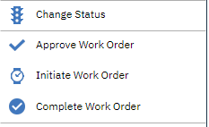
The ‘Change Status’ box appears and in the ‘New Status’ box the work ‘Approved’, click ‘OK’, your Work order status changes from ‘WAPPR’ to ‘APPR’.
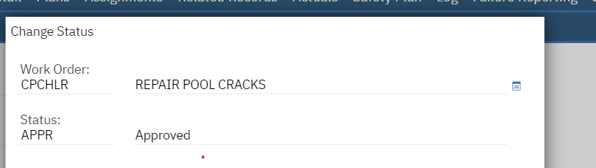

The Work order can be assigned to a ‘Lead’ and work can be started.
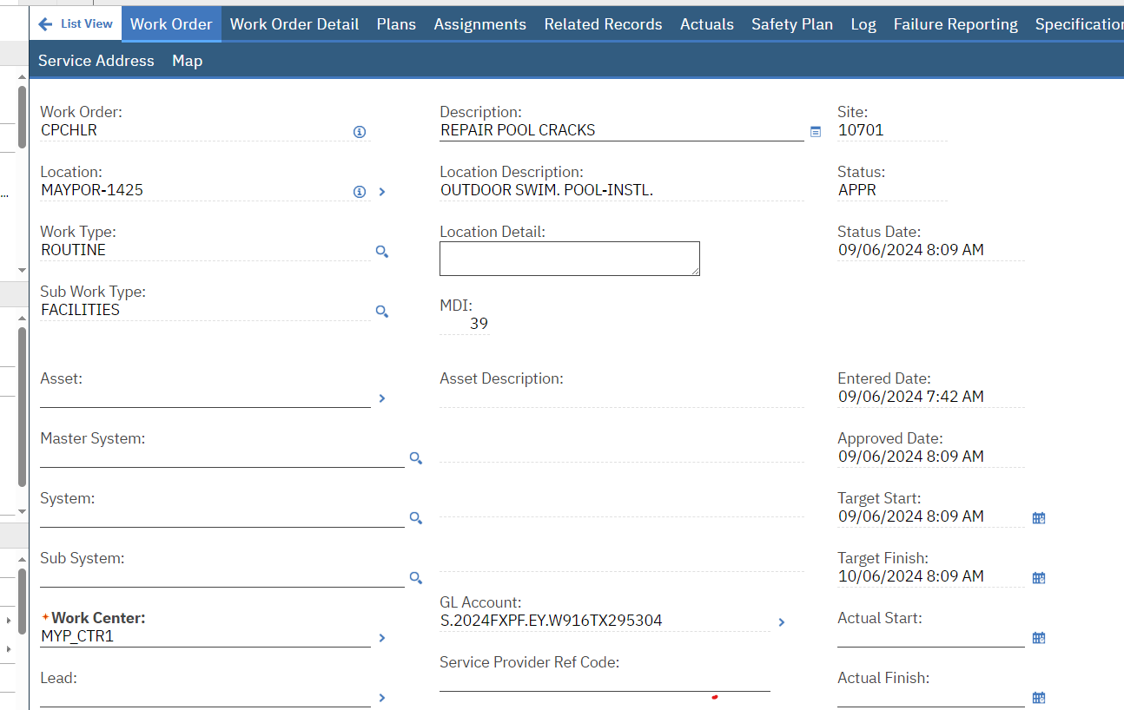

ENTERING LABOR AND MATERIAL
Labor and Material for in-house workforce will be imported on the Work order; material will be pulled from the Purchase Order module and Labor from the SLACADA interface.
After approving the Work order, you can add labor and/or material to the work order. Once Labor and/or Material is added to a work order it cannot be cancelled.
This step is for CONTRACTORS ONLY:
Go to the ‘Actuals’ tab.
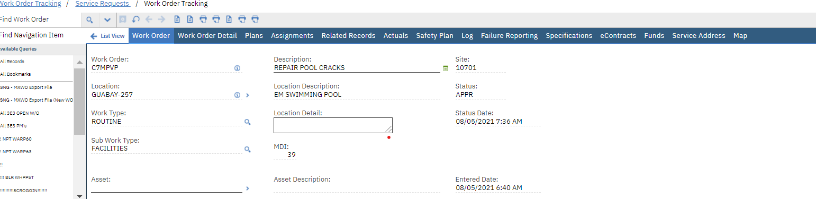

Enter ‘Labor’: Click on the Labor tab; then click on ‘New Row’.
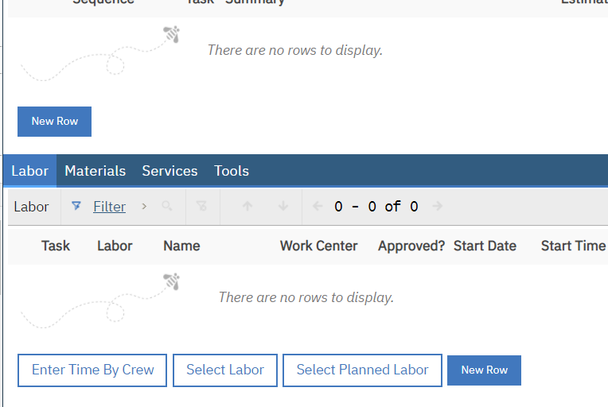

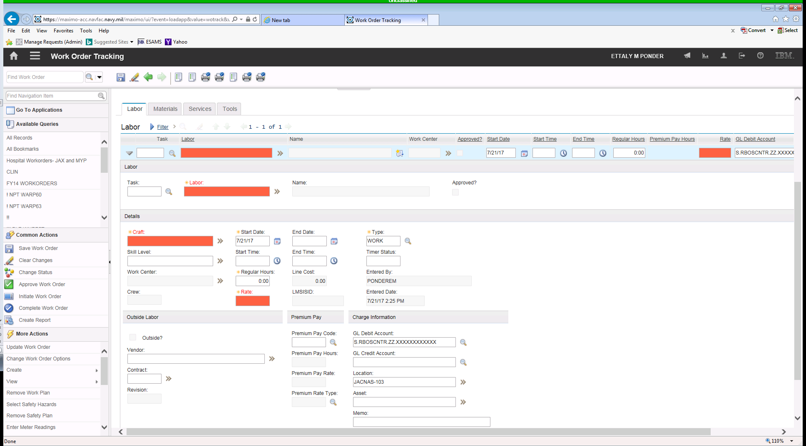

Enter all the required fields in Red.
- Labor – The employee labor code or the contract labor record. MYP_CTR1 (mandatory)
- Rate – The per hour rate of the employee performing the work. $0 (mandatory)
- Craft – The craft of the employee performing the work. (mandatory)
- Regular Hours – Number of hours to complete job. (mandatory)
- Start Date – The date of the work. (System defaults to current date – this can be modified). (mandatory)
- Everything else is automatically entered by Maximo. Once you save the record, you cannot make any changes. (Check for accuracy before saving.) Save the record.

Craft | Description
AM | AUTOMOTIVE MACHINIST
BA | BUDGET ANALYST
BS | BACKFLOW SPECIALIST
DE | DATA PROCESS EQUIPMENT
DI | DISPATCHER
EK | ELEVATOR MECHANIC
EY | PHYSICAL SCIENCE TECH
FB | FALLER AND BUCKER
FP | FIRE EQUIP TECH MECHA
FW | FABRIC WORKER
GL | GLAZIER
HW | HAZ WASTE HANDLER
MH | MAINTENANCE HELPER
MJ | MACHINIST MAINT
MQ | MOBILE EQUIPMENT OP
OA | OFFICE ASSISTANT
PG | PURCHASING AGENT
PK | SPRINKLER MECH
PS | PWR SUP SYS MECH
QM | ENGINEER MECHANICAL
QR | ENGINEER TECH ELECT
QY | AUTOCAD OPERATOR
QZ | ENGINEER ENVIRONMENT
SD | SANDBLASTER
SE | SMALL ENGINE MECH
SO | SEWAGE DISPOSAL OPTR
WO | WATER TREAT PLANT OP
YH | P&E A/C EQUIPMENT
YO | SHOP PLANNER (ELECT)
YT | P&E ELECTRONICS
ZY | MLC EMPLOYEE/YOKO
AA | TRANSPORTATION ASST
BD | BOILER PLANT LEADER
BP | BOILER PLANT OPERATOR
EH | ELECTRICIAN HV
FE | FIRE EQUIP TECH ELEC
FL | FORKLIFT OPERATOR
HD | HAZ WASTE DISPOSER
HX | HVAC WORKER
IF | INSPECTOR ROOFING
LS | LOCKSMITH
ME | MARINE ENGINEMAN
MI | MILLMAN
ML | MODEL MAKER
MR | MATERIAL COORDINATOR
MW | MAINTENANCE WORKER
OH | OVERHEAD EMPLOYEES
OM | ORDNANCE EQUIP MECH
PD | PIPEFITTER LEADER
QD | ENVIRONMENTAL SUPER
QK | ENVIRONMENTAL PROT SPEC
QL | LANDSCAPE ARCHITECT
QX | ENGINEER INDUSTRIAL
RE | RAILROAD ENGINEMAN
RW | ROOFER WORKER
SB | SUPERVISOR II
SF | GENERAL FOREMAN
ST | SHEET METAL MECHANIC
WC | WOODCRAFTER
WU | CRANE WEIGHT TESTER
YB | P&E BOILER/UTILITIES
YL | P&E SHEET METAL MECH
YP | P&E PIPEFITTER
YR | P&E RECURRING
YZ | SHOP PLANNER
CP | CABLE SPLICER
CW | CARPENTER WORKER
CY | COMPUTER SYS ANALYST
DA | DOMESTIC APPL REPAIR
DG | DATA PROCESS RPT GEN
EE | ELECTROMOTIVE EQ MEC
EO | ENGINEERING EQUIP OP
EQ | EQUIPMENT MECHANIC
FD | FUEL DIST SYS WORKER
FI | FINANCIAL
HL | HELPER
HV | HVAC MECHANIC
IM | INSTRUMENT MECHANIC
IV | INSPECTOR HVAC
LB | LABORER
MD | MACHINIST LEADER
MN | MACHINIST INDUST PLA
MV | MOTOR VEHICLE OPER
PB | SIGN PAINTER
PI | PIPE COVERER
PJ | PWR SUP SYS MECH LDR
PL | PLASTERER
QG | ENGINEER GENERAL
QN | MECHANICAL DRAFTSMAN
RH | ROOFER HELPER
RP | ROICC PROJ MGR
SH | DEPARTMENT HEAD
SW | SHEET METAL WORKER
TE | TELEPHONE MECHANIC
WK | WHARF BUILDER WRK
WW | WELDING WORKER
YI | P&E RAILROAD
YQ | P&E IND EQUIP MECH
YX | P&E WELDER
AB | AUTOMOTIVE MECH B&F
AE | AUTOMOTIVE MECHANIC
AN | MANAGEMENT ASSISTANT
AT | ACCOUNT TECHNICIAN
AW | ASPHALT WORKER
BE | BOILER PLANT EQP MECH
CA | CARPENTER
CF | CEMENT FINISHER
CH | CARPENTER HELPER
CL | CARPET LAYER
CT | CONTRACTOR
CX | COMPUTER ASSISTANT
FO | FIELD TRACTOR OP
FT | FLOOR TILE LAYER
GA | GARDENER
HM | HEAVY DUTY EQ MECH
IC | INSPECTOR ELECTRICAL
ID | INDUSTRIAL EQP MECH LDR
IP | INSPECTOR FACILITY
IQ | INDUSTRIAL EQP MECH
JT | JANITOR
LG | LAGGER
LR | LIFT STATION ROVER
MA | MARINE MACH REPAIRER
MB | MACHINIST ENGRAVER
MZ | MACHINIST HELPER
PE | PEST CONTROLLER
PX | PIPEFITTER WORKER
PZ | STREET STRIPER
QF | ENGINEER COMMUNICATN
QQ | ENGINEER TECH CIVIL
QT | ENGINEER TYPING
QU | ENGINEER TECH MECH
RD | RIGGER (DIVER)
SR | SPECIFICATIONS WRITER
SV | SURVEYOR
TD | TROUBLE DESK OPER
TM | TOOL ROOM MECHANIC
WP | WELDER/PIPEFITTER
YF | P&E REFRIGERATION
YK | P&E ROADS/GROUNDS
YM | P&E MECHANICAL
YN | P&E MACHINIST
ZZ | PROD GS EMPL
AC | AIR COND MECHANIC
AO | AIR COMPR PLANT OPER
BR | BARGE REPAIRER
CC | CLIMATIC CONT OP MEC
CS | CONTRACT SPECIALIST
DP | DATA PROCESS PROG
ED | ELECTRICIAN LEADER
EW | ELECTRICIAN WORKER
FA | FIRE ALARM MECHANIC
HE | HEATING EQUIP MECH
HH | HVAC HELPER
IA | INSPECTOR AUTO RPR
IB | INSPECTOR BOILER
IH | INSPECTOR HVY EQ
IS | INSPECTOR STRUCTURAL
IY | INSPECTOR QUALITY
IZ | INSPECTOR ELEVATOR
LD | LEADER
PF | PIPEFITTER
QC | ENGINEER CIVIL
QE | ENGINEER ELECTRICAL
QO | ENGINEER FIRE PROTEC
RM | RADIO/TV MAINT MAN
SS | SAWSMITH
TP | TILE AND PLATE SETTER
WT | WEIGHT TESTER
YJ | P&E FACILITIES
YY | P&E
AR | APPLIANCE REPAIRMAN
CM | CONSTRUCTION MECH
CO | CRANE OPERATOR
CR | CONTRACT REPRESENTATI
DN | DATA PROCESS NETWORK
DR | DRAFTSMEN
EB | ELECTRONICS
EF | ELECTRICIAN FIRE ALM
EL | ELECTROPLATER
EM | ELECTRONICS MECHANIC
EP | ELECTRICIAN PWR PLT
ES | EQUIPMENT SPECIALIST
GE | GALLEY EQUIP MECH
MS | MODELMAKER SHT/PLAT
MU | MOTOR WINDER
PA | PAINTER
PO | PAPER PULP MACH OPER
PR | PLANT OPERATOR
PT | PNEUMATIC TOOL OPER
QA | ENGINEER ARCHITECT
QH | FACILITES PLANNING
RB | RAILROAD COND/BRKMAN
SI | STRUCT IRON WORKER
SN | FOREMAN
TO | TELEPHONE OPERATOR
YV | P&E ENVIRONMENTAL
AS | AUTOMOTIVE TRANS SPE
AU | AUTOMOTIVE
AZ | TIRE REPAIRMAN
BC | BILLING CLERK
BH | BOILER MECH HELPER
CE | CHEMIST
CN | COMMUNICATIONS
DK | DECKHAND
EJ | ENGRAVING
GH | GENERAL HELPER
HO | HEAVY EQUIP OPERATOR
IX | INSPECTOR SPECIAL
LT | LETTERER & GRAINER
MC | MASON
MK | MODELMAKER METAL COM
MO | MATERIAL HANDLER
OL | OILER
PH | PIPEFITTER HELPER
PM | PLUMBER
PN | PNEUDRALIC SYS MECH
PP | POWER PLANT CONTROMAN
PW | PAINTER WORKER
PY | PLUMBING WORKER
QP | INDUSTRIAL HYGIENIST
RF | ROOFER
RO | RADIO OPERATOR
SP | SWIMMING POOL OPER
SU | SUPERINTENDENT
SX | SHEET METAL WELD WK
UH | UPHOLSTERER
UP | UTILITIES PROG SPEC
WD | WELDER
WH | WHARF BUILDER
YC | P&E CARPENTER
AD | TRANSPORTATION SPEC
BF | BOILER FOREMAN
BM | BOILERMAKER
CZ | COMPUTER SPECIALIST
DD | DIVISION DIRECTOR
DT | DATA TRANSCRIBER
EC | ELECTRICIAN (COMMUN)
EN | ELECTRICIAN
EX | ELECTRONICS WORKER
EZ | ELECT POWER CNTRLR
GM | GAS HEAT EQUIP MECH
IK | INSPECTOR CONTRACT
IL | INSPECTOR MECHANICAL
IN | INSULATOR
IR | INDUSTRIAL EQP REPAIR
IT | INSPECTOR SANITATION
KQ | KITCHEN EQUIP REPAIR
MF | METALFINISHER
MG | MODELMAKER GENERAL
MM | MAINTENANCE MECHANIC
MP | PROJECT MANAGER
MX | MASON WORKER
PC | PRODUCTION CONTROLLER
PU | PUMPING EQUIP MECH
QB | ENVIRONMENTAL ASSIST
QI | ENVIRONMENTAL TECHNIC
QJ | ENGINEER TECH ENVIRO
QS | ENGINEER STRUCTURAL
QV | ENVIRONMENTAL GEOLOGI
RT | RAIL TRACKMAN/RPRMAN
SA | SUPERVISOR I
SG | SITE MANAGER
US | UTILITIES SYS RPR/OPS
YA | P&E PAINTER
YD | P&E AUTO MECH
YE | P&E ELECTRICAL
YG | P&E GENERAL
YS | P&E STRUCTURAL
YW | P&E WHARFBUILDER
FM | Foreman
ET | Electronic Mechanic
UR | UTILITIES SYS RECURRING
MT | MACHINIST
EI | ELECT IND CNTRL MECH
TR | Tire Repairman (heavy)
RG | RIGGER
ER | ELECT EQUIP REPAIRMN
UT | UTILITIES OPERATOR
RA | REFRIG & A/C MECH

To enter ‘Material’: Click on the Material tab and then click new row button
Click on the ‘New Row’ button. (ASTERISKS ARE MANDATORY FIELDS)

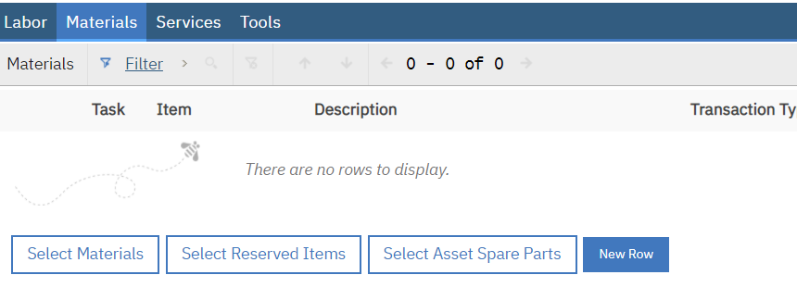
Click on the ‘New Row’ button. (ASTERISKS ARE MANDATORY FIELDS)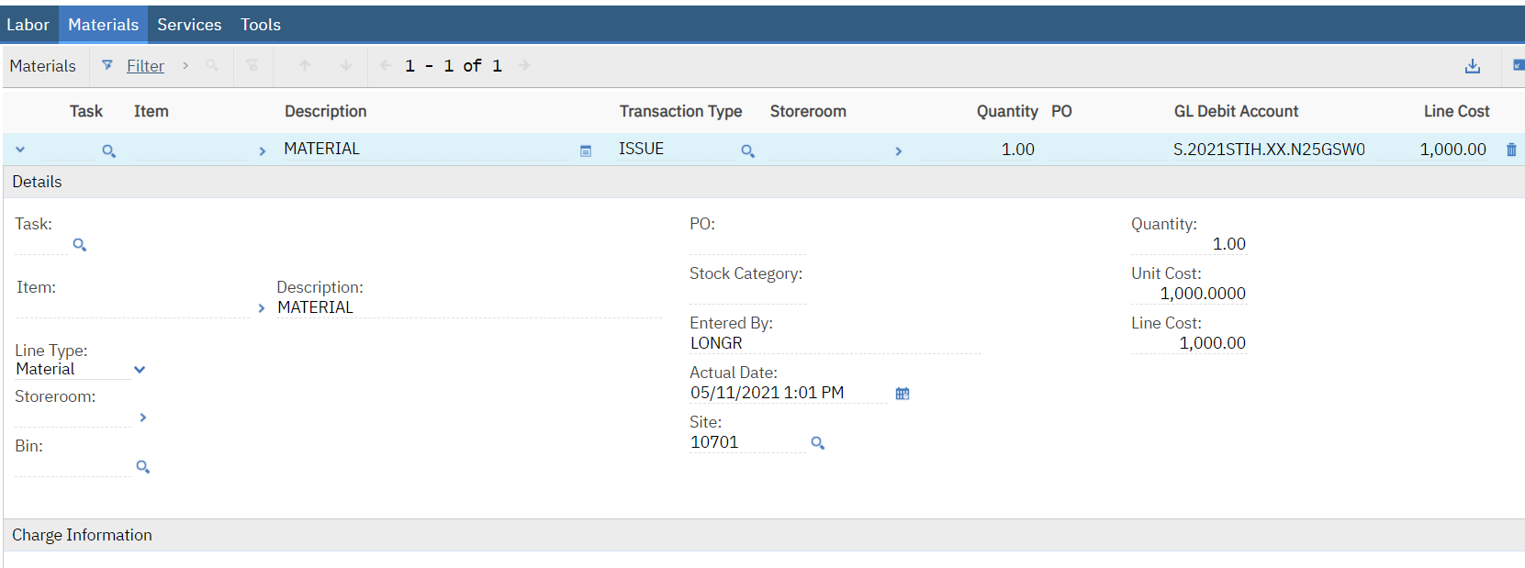

- Change the ‘Line type’ to ‘Material’
- Type the work ‘MATERIAL’ in the open space next to ‘Item’.
- Quantity leave as ‘1’
- Unit Cost, enter the total cost of the material.

Once you save the record, you cannot make any changes. (Check for accuracy before saving.) Save the record.
COMPLETING THE WORK ORDER
When completing WORK ORDER, click LOG tab.
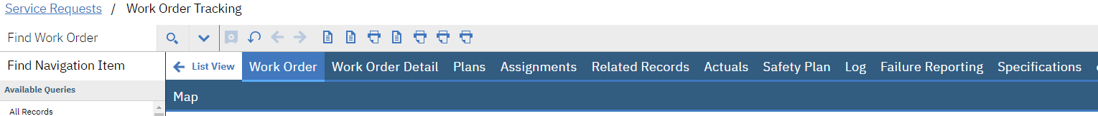
Then click NEW ROW.
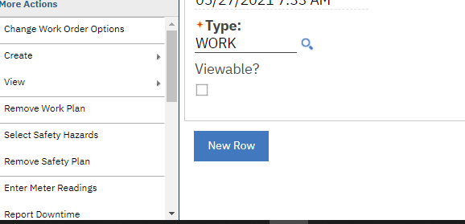

From the NEW ROW tab, information can be added to the WORK ORDRER in the details section.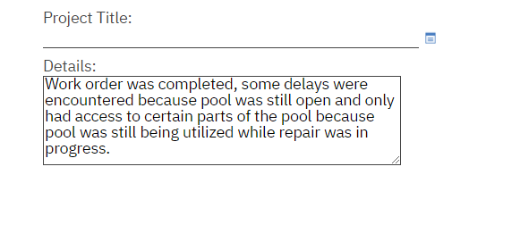
When the work has been finish, time has been charged to the Workorder, and it’s time to complete the workorder; you need to go to ‘Common Actions’, ‘Completed Work Order’
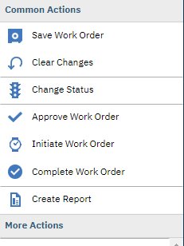
The ‘Change Status’ box pops up and the ‘New Status’ box has ‘Completed’. Click ‘OK’.
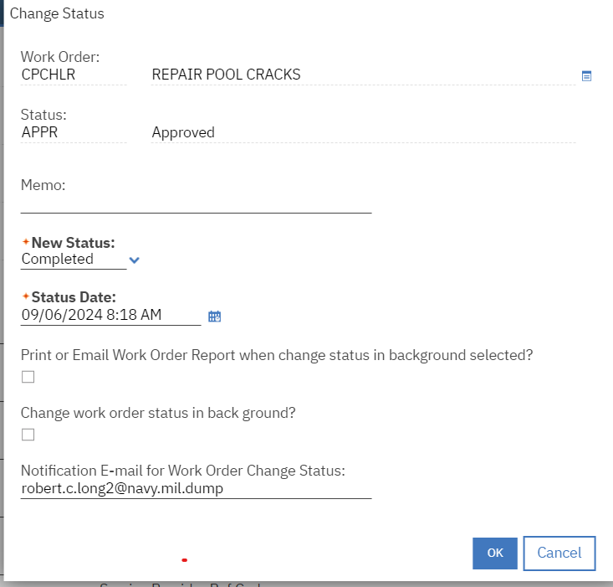

Process Completed.
How to create an asset
The easiest way is to duplicate an existing asset. Type in a known asset that is the same category that you want to create then click enter. Then when asset show up, click on the asset
Then click on duplicate asset.
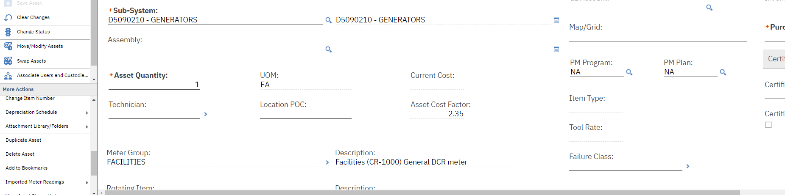
This is the screen you will see next. This is where you name the asset, give its location and installation date. When using MAXIMO, always use CAP’s. When naming assets in MAYPORT, it always starts with MYP-BUILDING NUMBER-ASSET TYPE- ASSET NUMBER. This is where you give a description of the asset. This box lets you put in additional comments also. An installation date is also required, if a date isn’t entered, it won’t let you save. (Utilities naming convention use UMAXXXXXXXXX, this should consist of “UMA”+ the Maximo number that will be generated when you click new asset).
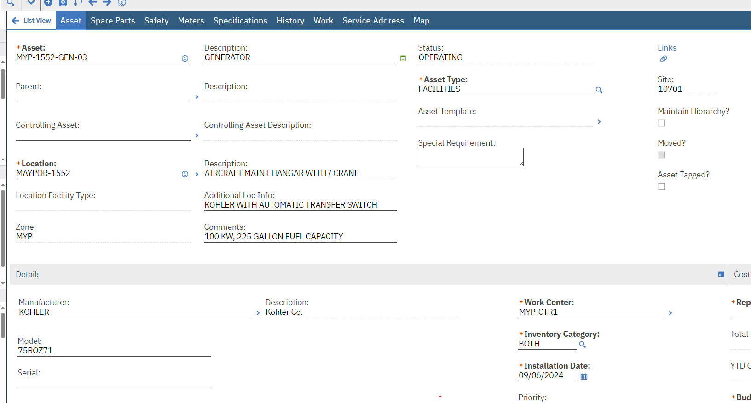

Scroll down father and this is where you add manufacture/ model and serial number. A replacement cost should be added also. You also need to change the PM program to P-KT.

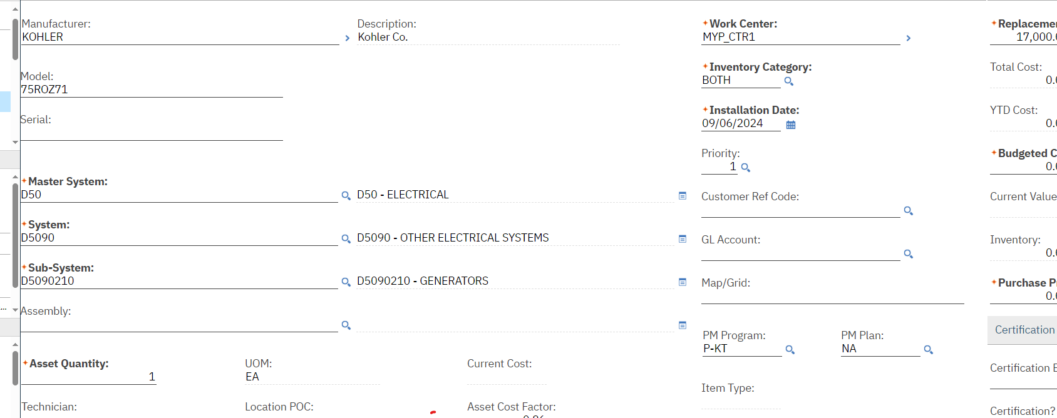

Next you need to click location and scroll down on the right side of drop menu and click select value.
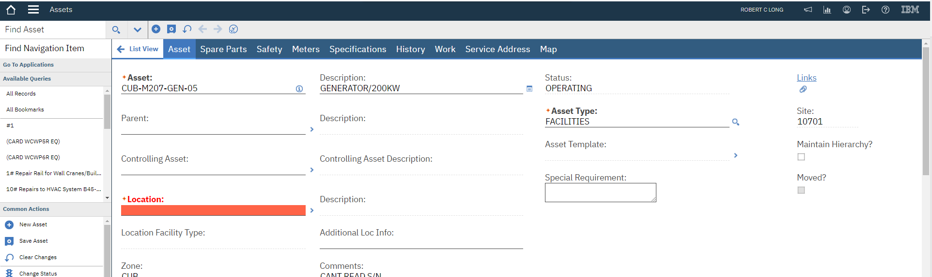

Then in the location box, type building number and click enter

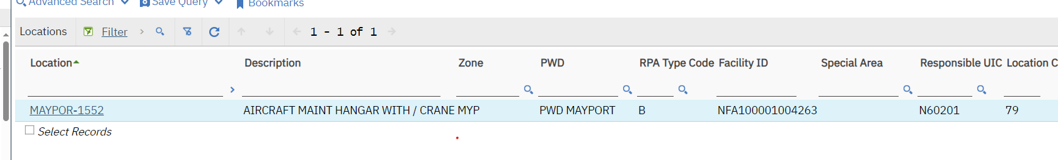
Then click GUABAY-M207

It will now add the facility number

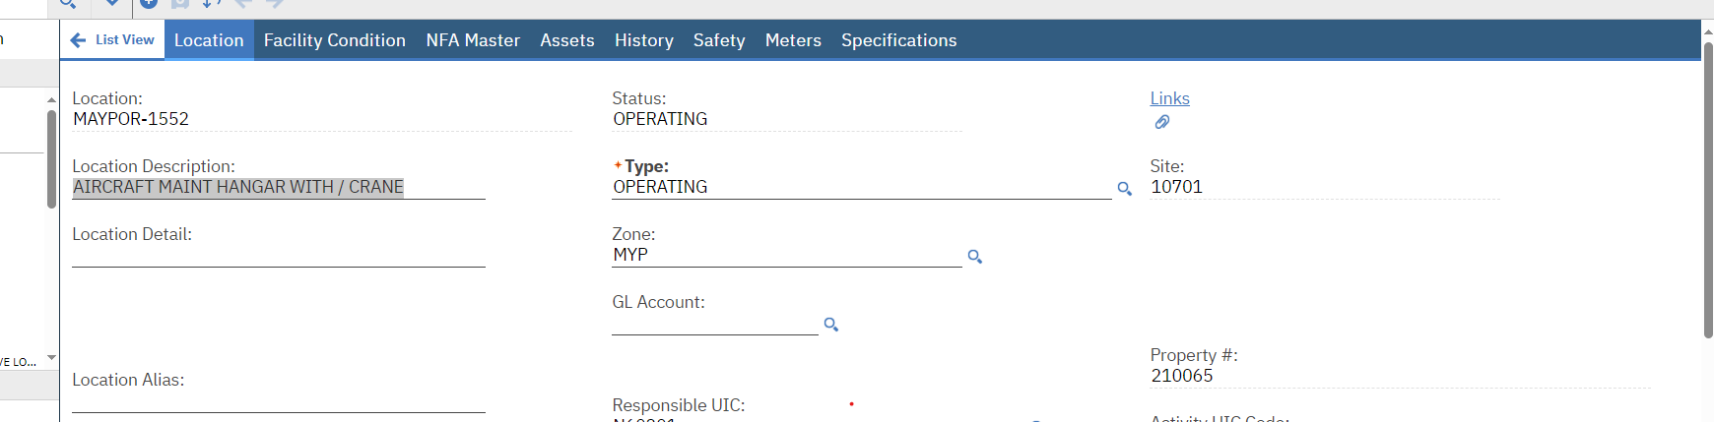
Now you need to save your new asset and the top of the screen will say the asset was saved.
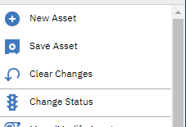

Then you’ll want to change status and make sure it’s listed as operating
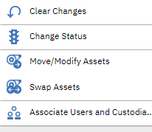
Then click the arrow and put it in operating status. 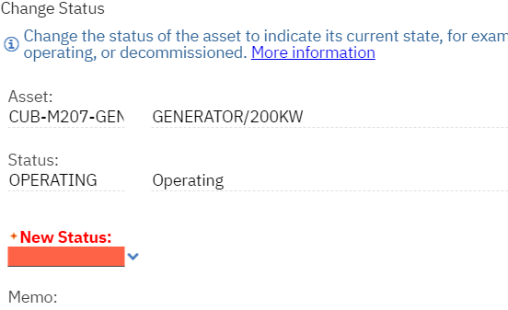
Now if you search for, it shows up as an asset and is in operating status
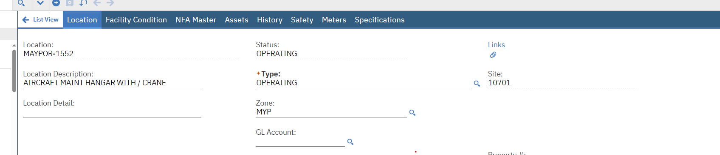

The last step is to do a direct condition reading of the asset you created. Directions on how to do enter direct meter reading is explained next.

This was created using the MAXIMO TEST SITE! This asset will not show up in regular MAXIMO and was only used to show how to create an asset.

How to do a meter reading of an asset. Start by clicking asset

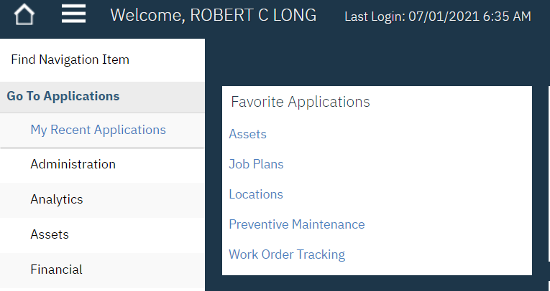

Under the asset section, type in the asset number and click enter 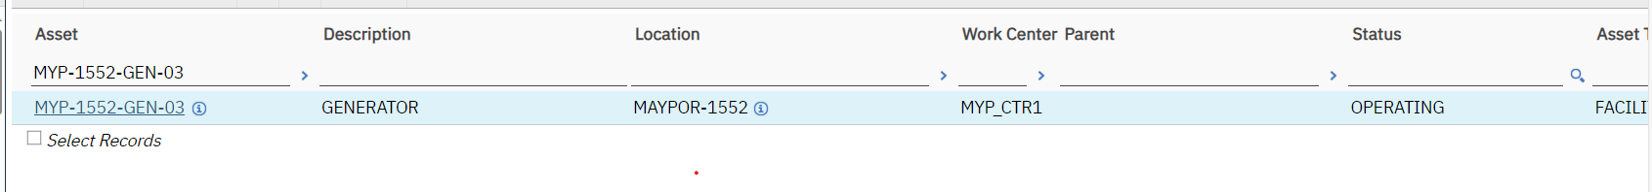

Then click enter on asset number
Then click on the enter meter reading tab on the left side of the screen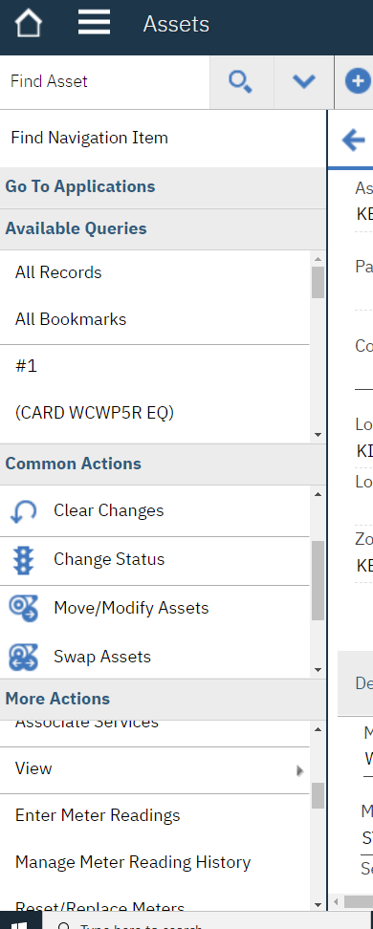

Then under new reading, click the magnifying glass

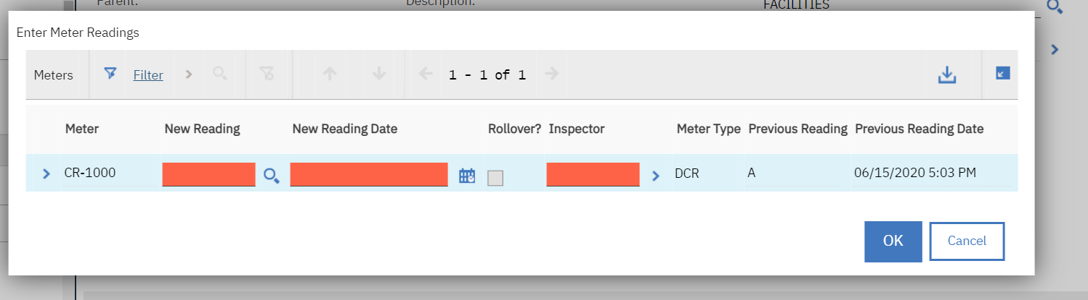

This is where you select the grade of the asset, click the value of the asset

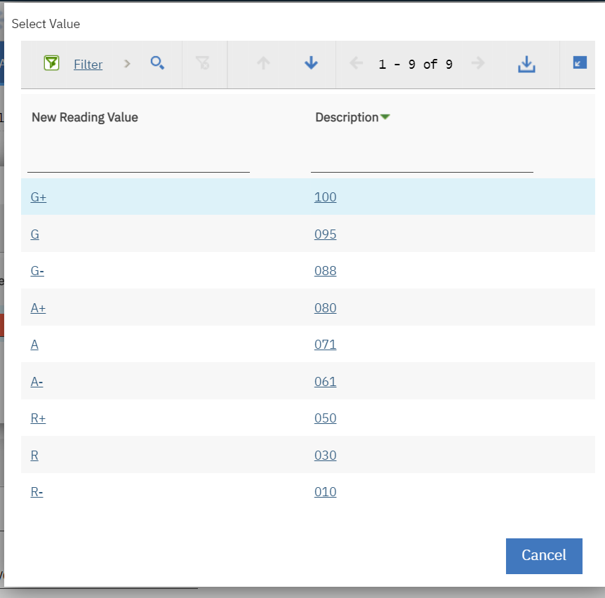
I selected A for the asset grade for demonstration as shown under new reading. Then click ok, your asset will have its new grade.

